EE Year-1

Vigneshwaren Sunder

20021065

EE Year-1

Line Following Robot

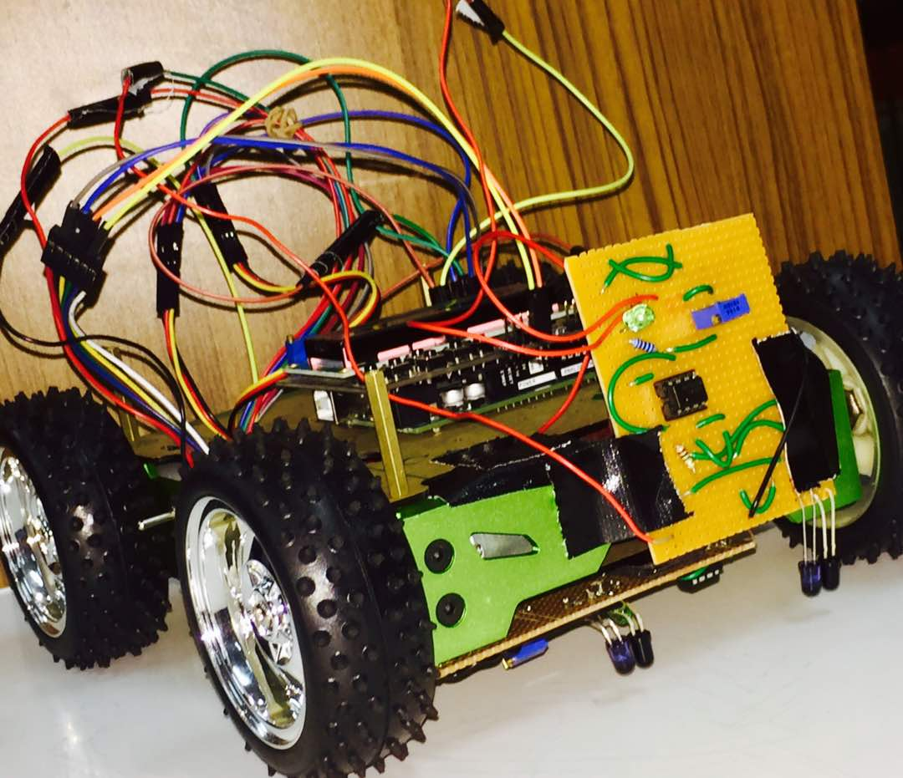

1. **INTRODUCTION:**
   1. **About the project:**

A line follower robot is a bot that follows a given path. This bot is introduced because in many of the industries we have seen that many heavy components which they have to move from one place to another place which is not possible without the help of machines. In this project, we have made a self-operating robot that detects and follows a line that is drawn on the floor using Arduino UNO. The path consists of black and white surface. The main objective of the robot is to simply sense the colour and complete the path without going off track. We have used 2 IR sensors to detect the track and 4 DC motors with encoders to move the bot. Arduino UNO acts as a microcontroller which gets the input from the sensor and sends it to the motor driver and thus makes the DC motors to rotate in desired speed and direction. The car can be broadly classified as 3 sections.

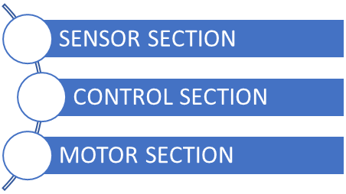Fig:1.0

* 1. **Basic Design and Construction:**

The following are the materials used to built the line follower robot,

* Hercules Base
* IR Sensors
* Amplifier and comparator
* Arduino UNO
* Motor Driver(6-20V Power supply)
* LiPO Battery(11.1V Power supply)
* DC motors with encoders and wheels
  1. **System Overview:**

Fig:1.2

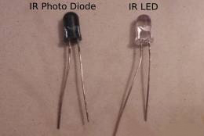**IR Sensors:** This acts as the main input source of the robot which detects the line. It has an IR emitter and an IR receiver. We can use any number of IR sensors. Here, we have used 2 IR sensors to serve as inputs. A photodiode is a type of photodetector capable of converting light into either current or voltage, depending upon the mode of operation. The term photodiode can be broadly defined to include even solar batteries, but it usually refers to sensors used to detect the intensity of light IR Photodiodes are semiconductor devices responsive to high energy particles and photons. Photodiodes operate by absorption of charged particles and generate a flow of current in an external circuit, proportional to the incident power. Photodiodes can be used to detect the presence or absence of minute quantities of light and can be calibrated for extremely accurate measurements from intensities below 1pW/cm2.

This IR sensor circuit is designed using 1 IR LED and 1 Photodiode. This circuit works on the reflection criteria. IR LED and Photodiode is placed adjacent to each other. When no IR

Fig: 1.3

light falls on the IR Photodiode the resistance of the diode falls in the range ohm Mega ohms or approximately infinity. When any reflecting surface (White surface) comes near to IR LED and IR Photodiode pair the reflected light of IR LED falls on the photodiode which rapidly decreases the resistance of the Photodiode and photodiode starts conducting.

Fig: 1.4

**Arduino UNO:** This is going to be the main processing unit of the robot. It acts as a micro-controller which operates all other components used based on the inputs given.

Fig: 1.5

**Motor Driver:** Arduino UNO is not capable of controlling and supplying a power source to the DC motor directly. Hence, motor driver acts as a median between the Arduino UNO and DC motors. It receives the command from the Arduino UNO and drives the motor accordingly.

Fig: 1.6

**DC Motors:** We attached 4 DC motors with encoders and wheels to the car. The incremental encoders that we used gives the information about the position of the shaft inside the motor in the name of counts.It converts the angular position or motion of the shaft and gives a digital or analog signal.

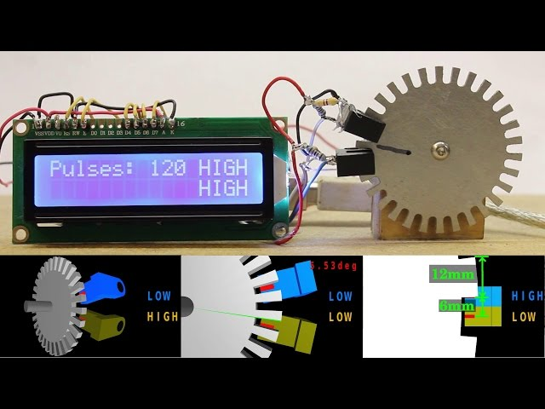

Fig: 1.7

A rotary encoder can be defined as a sensor in which a light sensor is used in conjunction with a slotted disc in order to determine how far a rotational mechanism has turned. The slots in the disc either allow light to pass or block it, allowing the light sensor to send data to the microcontroller, which can add these pulses and determine how many 'slots' the encoder has passed.

**LCD Keypad Shield:** The Hitachi HD44780 driver 16x2 LCD screen is connected to the Arduino UNO, which serves as an output device. It prints the value of the encoders, distance traveled by the car, time taken to complete, etc.,

1. A picture containing text, clock, sky, table

   Description generated with very high confidence**IR Sensor circuit diagram:**

Fig: 1.9

**2.1 Working of the circuit:**

IR sensors have 1 emitter and 1 reflector. The robot uses a combination of IR Photodiode and IR-LEDs to sense the presence of the line. An IR Photodiode is a resistor whose resistance is proportional to the light falling on it- greater the light, lesser the resistance and visa-versa. The basic principle underlying this project is that objects light in colour radiate the light falling on them while dark coloured objects dont. So when the sensors are above the black line the light emitted by the IR- LED is not radiated by the floor, hence the resistance of the Photo-diode increases. The opposite happens when the robot back on the white surface. So when the sensors are above the black line the light emitted by the IR- LED is not radiated by the floor, hence the resistance of the Photo-diode increases. The opposite happens when the robot back on the white surface. In our robot, the IR Photodiode is used part of a voltage divider circuit. When the robot is on white surface the light emitted by the IR LEDs fall on the IR Photodiode and decreases its resistance. This, in turn reduces the voltage at Vout. When the robot is on the black line, the light emitted by the IR- LEDs does not reach the IR Photodiode, hence its resistance increases

In this, we used NPN LM358 op-amp. It amplifies the low-intensity sensor signal and provides it to the input of the motor driving circuit to sense the change in resistance we use the voltage divider circuit. Thus we get the variation of voltage which is sensed by a comparator. A comparator is a device which compares the 2 input voltages and gives the output as either high or low

**2.3. Use of Comparator in IR sensor:**

The comparator requires two input voltages. One is from the photo-diode and the other is generated by using a potentiometer. The second voltage is also called as the reference voltage for that sensor. We can vary the reference voltage by using the potentiometer. The reference voltage should be the mean voltage value of the sensor inputs measured with and without lights. If we connect Inverting Input of Comparator to potentiometer and Non-Inverting Input to photo-receiver, the only difference observed is that at the white surface we will get Low output and for black surface, we will get High output.

A picture containing monitor, indoor

Description generated with high confidence

The output of the IR sensor signal can be seen on the oscilloscope. The analog signal gives a sinusoidal wave and a digital signal gives a square wave. It can be seen that the output is high when the intensity at the receiving sensor is high.

Fig: 2.0

**2.4. The Algorithm of the car based on the input received**.

The movement of the car based on the input given to the motor driver is given in the form of a flowchart.

A picture containing tennis, racket, ball, sky

Description generated with high confidence

1. **RESULTS:**

* The car successfully completed the track in 1 minute 17 seconds.
* Fast course correction, able to turn the car car accurately without going off track.
* Able to display the time taken, distance, number of counts of the encoder on the LCD screen.

**3.1. Discussions:**

* Serial communication was a major issue during the construction of the bot. Two foreigners who speak different languages are tasked to work together by establishing a protocol through the language they understand and sending a series of bytes between the microcontroller through serial communication.
* Sensors turned out to be too big to fit in front of Hercules. We somehow managed to fit it accurately underneath the bot.
* The sensors were not placed at equal distance from the ground. Therefore, we needed to optimize the sensitivity of the sensors by changing the reference voltage until an optimum sensitivity is achieved.

**3.2. CONCLUSION:**

The activities done in project week 2 gave a broad explanation and knowledge about IR Sensors and microcontrollers. The line following robot is equipped with sensors and microcontrollers is capable of following any tracks and also has a lot of advantages in industries and future transportation systems. The following are some advantages and characteristics of this line following robot,

Increased productivity, safety, efficiency, quality of products. Can work in hazardous environments, no need for support. Need no environmental comforts. Have repeatable precision at all times. Can be more accurate than humans. Have many capabilities beyond those of humans. Can process multiple stimuli/tasks simultaneously. A robot can work without sleep. So it can work 24/7/365. Apart from advantages, there are some disadvantages too. They are as follows:

Robots take the place of many humans in places like factories. So the people have to find new jobs or be retrained. So a MAJOR disadvantage is that the robots take the place of humans in several situations. Another disadvantage is that there is quite a high initial cost for the robot and the software and equipment that you need to use with the robot

1. **References:**
2. <http://en.wikipedia.org/wiki/Dcmotor>
3. Simple Line Follower. <http://www.societyofrobots.com/member_tutorials/node/62>
4. IE Sensors. <https://en.wikipedia.org/wiki/Passive_infrared_sensor>
5. DC Motor with encoders. <https://en.wikipedia.org/wiki/Rotary_encoder>
6. Applications of Line following robot. <http://iwemag.info/advantages-of-line-follower-robot-jiz/>
7. **APPENDIX:**

The codes used for line following robot is given below.

A screenshot of a cell phone

Description generated with high confidenceThis code makes the motor driver to command the DC Motors to act accordingly to the input given by the IR sensors.  
A screenshot of a cell phone

Description generated with very high confidence

Fig: 2.1

Fig: 2.2

A screenshot of a cell phone

Description generated with high confidenceThe above codes are used to declare the IR Sensors as inputs, and also prints the values on the LCD screen. It instructs the motor driver to make the DC motor to run accordingly to the inputs given. The speed and direction at the DC motors should run is given in the form of code and uploaded to Arduino.

<ALL RIGHTS RESERVED>

Fig: 2.3